Introduction

This research project was created to discover whether audience participation and social media have an important role in the Stop Funding Hate Campaign (2016). It uses secondary research and qualitative, primary research, in the form of a focus group. The focus group used a mixed group of 10 females and males aged between nineteen and twenty-two to understand their views on whether social media campaigns, like the Stop Funding Hate Campaign, can be successful and to gain insight into what they know about the campaign. The focus group lasted for approximately forty-five minutes and was in an informal setting, where the group leader (myself) was also involved. This style of focus group and setting were chosen so that the participants would feel comfortable when being asked personal questions. The Stop Funding Hate Campaign started in August 2016 with the aim to stop companies advertising in three tabloid newspapers; The Sun, Daily Mail and The Daily Express, which its founder says use sensationalist and often hateful articles and headlines to scaremonger and create division to sell more papers (Wilson, 2016).

Results and Discussion
The overall results collated from the focus group showed that many partakers had heard of the Stop Funding Hate Campaign and agreed with the overall question of the research project. As all participants were extremely active on social media daily, visiting both Twitter and Facebook “countless” times a day. Therefore, they had knowledge of the campaign for quite some time, and had repeatedly seen it on their social media feeds as it became more virally aware. This demonstrated that campaigns that attack a position of power, like newspaper companies, spread their message quickly because it fights against the norm and there is no control of their proximity when promoted through social media, agreeing with Bruns and Burgess’ view that emerging issues are responded to with great speed (2011).

It was also discussed by the group that for a campaign, like the Stop Funding Hate Campaign, to be successful it must be a unique new idea to spark an interest. Most group members (six out of ten) had heard of the campaign independently through social media. Three had heard of it from myself when asked to participate in the focus group, then went on to do further research before participating; the last member heard about it through print media when Lego first announced that it would no longer advertise in the Daily Mail, in September 2016.
The six who had earlier heard of the campaign had not intentionally been looking for the campaign when they discovered it, it had been ‘shared’ by a friend onto their social media feed or promoted through online cookies, meaning they must have looked at similar content before. From this it is impossible to infer that whilst social media audiences are often seen to be active, the way information is discovered through them is passive, and like that of traditional print media, for example a newspaper. As opposed to finding the information for themselves it had been placed in front of them to absorb whilst they scrolled through their newsfeed, highlighting ideologies of the hypodermic needle theory (Chandler and Munday, 2011).

One member used the word “scrolling” to describe the inactive way that they use social media, suggesting that they are simply scanning what is on their screen at the time, and not interacting with the content they see. This knowledge also suggests that while some users are clearly active, creating the buzz and spreading the word of the campaign, many are not. From this it can be inferred that while they are interested most users would not go on to participate in spreading the word further. In addition, this suggested a hindrance of online campaigns, as it may mean that without a buzz and the active minority a campaign like this would not spread.
As earlier focused on in the literature review it was interesting to see what the group thought about ‘hate’, ‘hate crimes’ and tabloid newspapers in association to these. A word cloud of synonyms was created (appendix 1) when the group's opinion was asked including words such as ‘prejudice’ ‘dislike’ and ‘discrimination’ showing the same negative perspective as that of Perry (2001). From here participants built up what a hate crime from the connotation of these words. Their views agreed with that of Perry’s and the definition from the Oxford English Dictionary (2016) of what hate is. This highlighted that there is a wide understanding in society of what hate and hate crimes are, potentially because of how often they are reported in the media and news in current day. Furthermore, during question 5 of the focus group it was asked if the participants could describe their opinions of tabloid newspapers, specifically those targeted by the campaign; The Sun, The Daily Mail and The Daily Express. Another word cloud (appendix 2) emerged from this with members describing tabloids as being untrustworthy, cheap, racist and sensationalist. In response to another question posed about whether the participants had ever felt offended by one of these newspapers for their content every member replied yes, or that they felt shocked and bad on behalf of those it singled out. This implies that the social media campaign could be successful as it promotes a view many hold.

Whilst reviewing the primary research another point created by the participants was that the campaign has diminished recently. After it went viral in December 2016 little information disseminated by it has reached the same viral levels or popularity on social media. They felt that they were hearing less about it since the new year began. This could suggest that a social media campaigns’ success is time limited, creating a weakness: it must be influential and have an impact quickly, if it wants to have a lasting effect. Yet strength still lies in the fact that even though it has not been a long-term solution it has raised awareness to more people, with over 218,702 followers to date (Facebook, 2017). In addition, social media provides a free way of campaigning so anyone can do it and speak liberally which is another strength in this type of campaigning. This supports Gillian’s (2007) view that social media provides a new way for the masses to be active, as opposed to traditional means of protest which take a lot of planning and will only be seen by a few spectators.

Finally, the group concluded that the biggest issue with the campaign was that even if big brands like John Lewis do stop advertising in a tabloid newspaper there will always be another company willing to take its place. During the discussion participants hypothesised that the price of advertising in these papers would change if large companies pulled out, and small companies may take their place. Suggesting that no matter what there will always be a company willing to advertise in a paper, even if the disagree with its morals. Implying that the reality of the campaign having a true effect on these newspapers is very unlikely. This further shows that whilst social media and audience participation create a successful campaign, in the case of The Stop Funding Hate Campaign the means of it are flawed, making the campaign less likely to work, despite it’s good message.

Critical Assessment:
For this critical assessment of my research project I am going to use Bain’s Five R’s framework (1999) to create a reflection of my approach. I will use the ‘R’s’ of the model as subheadings to make it systematic and make sure that all points are covered.

Reporting and Responding:
One of the most prominent issues with this piece of research was that because the campaign is a new topic there is no academic research surrounding it, making it hard to do secondary research specific to this campaign. I resolved this issue by looking at other research about online social media campaigns from a marketing, activist and news aspects so that all bases surrounding the campaign were covered. As well as considering sources surrounding social media, audience participation, hate crimes and newspaper readership statistics.
Despite the issue of there not being research about the topic specifically I enjoyed the challenge of finding relative information to my topic. In addition, the originality of the research meant I didn’t know which way the project would take me, so it was quite exciting to find out if my objectives and aims would turn out as I expected, or if I would be completely off the mark with my personal views. During this process, I did however question whether my project would benefit from me widening my question to social media campaigns in general; after more research, however, I found that this would not be necessary.
One issue I faced early on in this project was that I had originally wanted to conduct an interview with the people running the Stop Funding Hate Campaign, to find out their personal views of the campaign they had started. To do this, I tried contacting them through the available means to plan the interview, meanwhile my deadline loomed nearer and I did not hear back from them until it was too late. Whilst I did this I formulated a back-up plan of using a focus group to attain primary research instead. To my unfortunate luck the campaign founders replied to my messages two days after my deadline! Yet I have learnt from this mistake that better time planning and organisation may have meant my message was seen sooner, as I sent it towards the end of my schedule rather than the beginning. Meanwhile the focus group plan did work and successfully collected qualitative data from an audience perspective which my question needed.

Relating:
As the campaign is a current event it covers a current issue: should brands disassociate themselves with newspapers that promote a different moral message to that of the brand’s image? This made it easy to relate my own views and emotions to the project and use them to create an understanding of my question.
In terms of professional in sight it was a matter of deciding what was relevant from other social media campaigns and applying this to the campaign I have been looking at. It was not difficult to find appropriate literature for this part, however I found difficult to do this whilst writing my methodology. There are so many views on research methods, specifically focus groups, so deciding which ones were appropriate for my research proved difficult. I did also question part way through planning this part about whether a quantitative research method, like surveys would be a better form of data collection as it would target a wider audience and every age demographic of Facebook users. This could be something to add to the project and analysis further in the future as it would give more insight into my question where research is scarce.

Reasoning:
During the focus group, it was important and sometimes hard to make sure that the agenda was kept and we did not go off topic too much. With a time limit set I had to make sure that all the questions I wanted to ask were covered and with sufficient detail. This meant quickly deciding when to move onto the next question, but also making sure that all members of the group had the chance to hold the floor and offer their views. I feel that because I had a strong set of objectives and aims from the first part of the project, I could use these to guide me in making sure I collected the appropriate notes during the data collection.
In hindsight, my focus group had 10 people, the maximum suggested size by Morrison (1998), and very often it felt like people didn’t go into full depth of their views because I needed to move onto the next person to get a range of opinions. If I were to redo the project I would chose to have less people in the focus group, perhaps 6, so that the participants had more opportunity to share their views.
Developing the previous point further I also found that there was so much data produced from my focus group it was difficult to decide what to use in my data analysis. This could be another reason to use quantitative data in the future. For each question the participant’s opinion would limited to a choice of answers, as opposed to being limitless during the focus group.

Reconstructing:
In summary, I enjoyed the research project as I had the freedom to choose what topic I looked at and how I carried out all the research. For this I chose to look at social media campaigns, specifically the Stop Funding Hate Campaign as it has been a buzz topic on social media recently, and I have enjoyed seeing it develop whilst creating this piece of research.

Word count: 2151

Appendices:

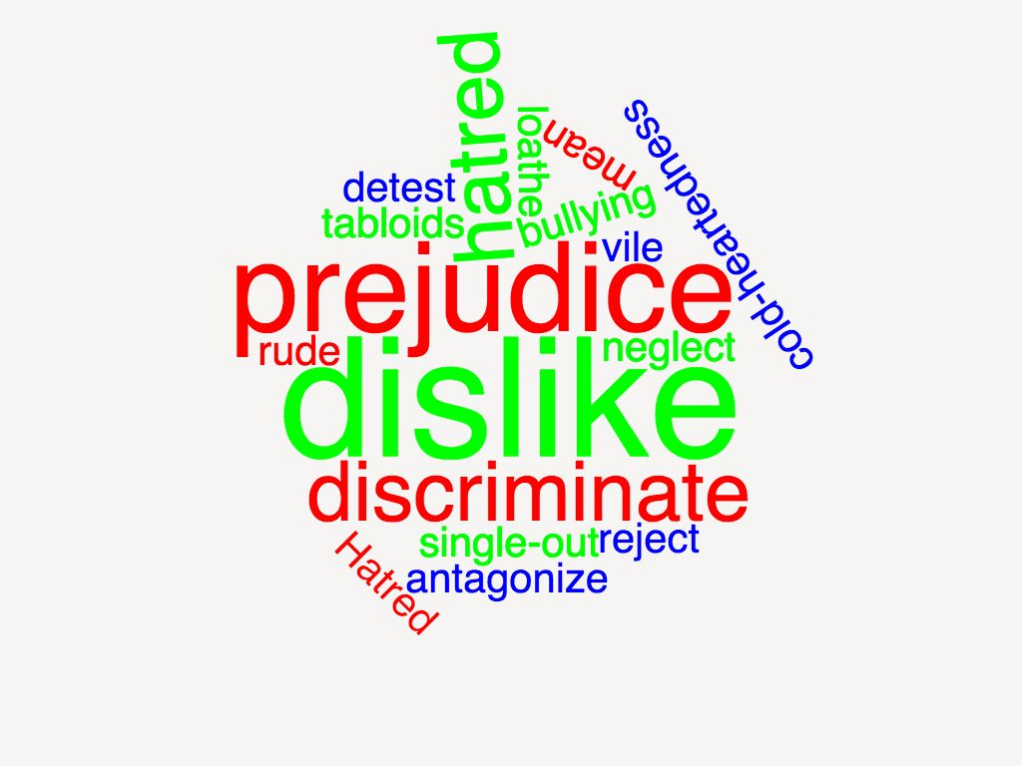
appendix 1: A word cloud of adjectives used by the participants of the focus group to describe what hate and hate crimes are.

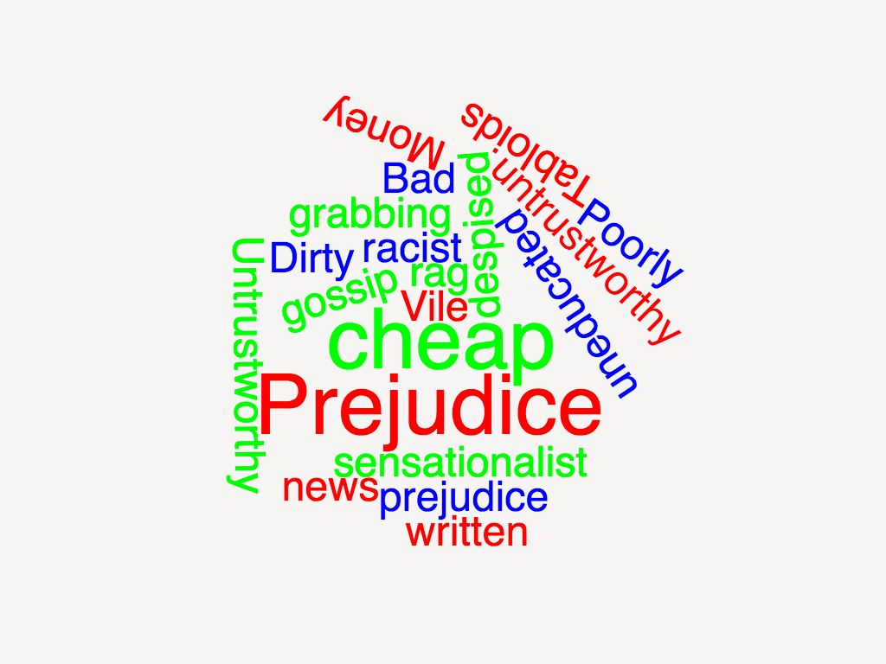
Appendix 2: A word cloud of adjectives used to describe tabloid newspapers by the participants of the focus group

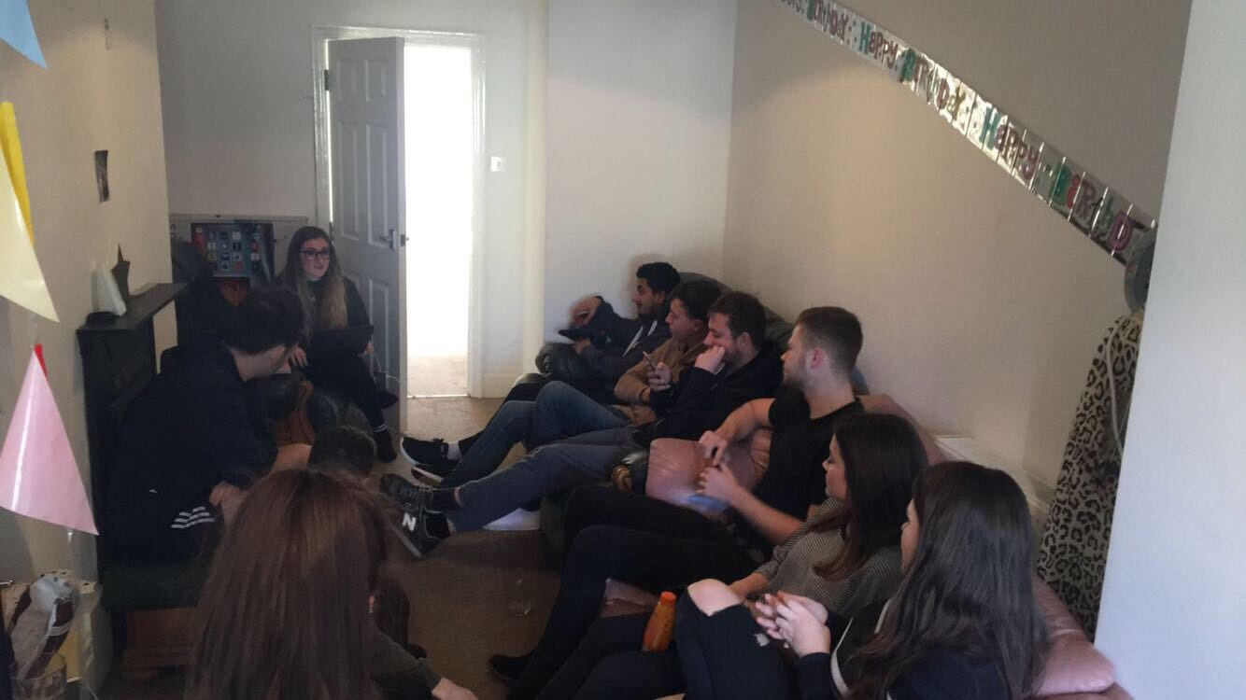

Appendix 3: Image of the focus group in action.

References:

Bain, J.D., Ballantyne, R., Mills, C. & Lester, N.C. (2002) Reflecting on practice: Student teachers' perspectives.

Brunns, A. and Burgess, J., 2011. The use of Twitter hashtags in the formation of ad hoc publics. 6th European Consortium for Political Research General Conference. Reykjavík, Iceland. Available from: http://eprints.qut.edu.au/46515/ [Accessed 24 November 2016].

Chandler, D and Munday, R., 2011. A Dictionary of Media and Communication. 1st edition. Oxford: Oxford University Press.

Facebook., 2016. Stop funding hate - likes. Available from: https://www.facebook.com/pg/stopfundinghate/likes/?ref=page_internal [Accessed 12 November 2016].

Gillin, p, 2008. Journal of New Communications Research. Society for New Communications Research and Institute for PR, II (2).

Gillin, p, 2007. The new influencers: A marketer’s guide to the new social media. Choice Reviews Online, 45 (01), 45–0362–45–0362.
Morrison, D. E., 1998. The search for a method: Focus groups and the development of mass communication research. Luton, Bedfordshire, U.K: University of Luton Press.
Perry, B., 2001. In the name of hate: Understanding hate crimes. New York: Routledge Member of the Taylor and Francis Group.

